MARC CHRISTIAN ESTOLLOSO
CLYDE VINCENT NAIG
JOSHUA ANTOY

- When you successfully used the payload to overwrite the secret key variable, which pillar of the C.I.A. triad did you primarily violate? Explain why.

- Overwriting the secret key primarily violates the Integrity pillar of the CIA triad. This exploit alters critical data in memory without authorization, undermining data accuracy and trustworthiness

- What specific vulnerability category did you exploit when you entered a string longer than 8 characters?

- Entering a string longer than 8 characters exploits a buffer overflow vulnerability. It exceeds the fixed buffer size (e.g., char), allowing overflow into adjacent memory like the secret key

3. Why is your solution (#4 The Fix) more effective than simply "asking users to be honest"?
- Solution #4 (likely input validation, bounds checking, or secure coding) enforces technical controls automatically. It blocks exploits reliably, unlike "asking users to be honest," which fails against malicious actors who ignore requests.
4. Imagine this was running the control system for a local power grid.
* Who might want to exploit this vulnerability?
Power Grid Exploiters
- Nation-state actors (e.g., Sandworm) seeking geopolitical disruption.
- Hacktivists or terrorists aiming for blackouts.
- Insiders or industrial rivals for sabotage.

* What would be the real-world consequence if the secret key (controlling the power switch) was overwritten by a pro cyber-attacker?
Attack Consequences
Overwriting the secret key could let an attacker flip the power switch, causing outages, economic damage, safety hazards, and grid instability (e.g., frequency shifts from synced loads)

References
https://www.perplexity.ai/search/7d5ad8f1-837f-4ac5-884b-8b322e421300
https://www.fortinet.com/resources/cyberglossary/buffer-overflow
https://www.wired.com/story/crash-override-malware/
https://www.ironnet.com/blog/cyber-attacks-on-the-power-grid

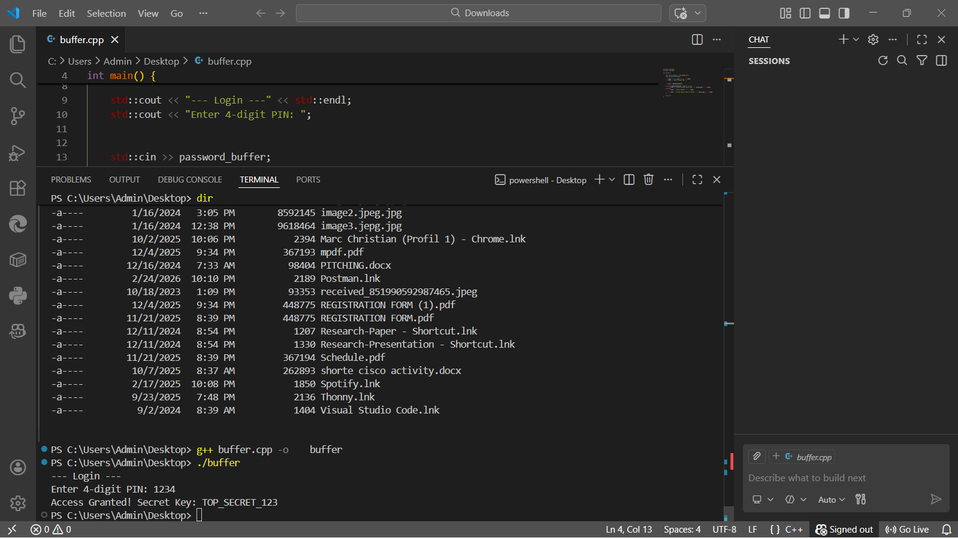
SCREENSHOT

